1. “We must all try, in every way we can, to send the message that reading is critical to our lives and to the life of our nation.” - James H Billngton, created National Book Festival with Laura Bush, wife George bush

Answer: George Bush virus(It starts by boldly stating, "Read my docs....No new files!" on the screen. It proceeds to fill up all the free space on your hard drive with new files, then blames it on the Congressional Virus.)

1. Playfair cipher for “Do the right thing”

Answer: alphabet inc



Well, all information looks like noise until ____________________.

Answer: you break the code

Hint: 0441569595- ISBN-10

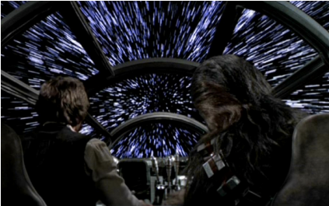

When you finally jump to __________ you win xaward

What is X?

Answer- Crazy But Cool award.

You jump to hyperdrive🡪HyperOs HyperDrive🡪HyperDrive4 (16 GB) won Custom PCs Crazy But Cool award.

HINT: seagate.

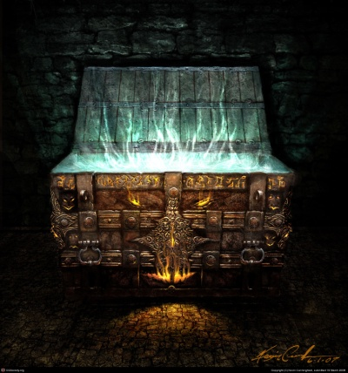

Pandora box – secret/mysterious – arcane –online event innerve - technical fest IGDTUW

Answer: Kashmere Gate



Wake up! Don’t keep on putting that sound off. Go for a walk.

Nazi – World war II

Putting that sound off- here ‘that’ refers to alarm and the sound is ‘tring tring’ 🡪alan turing

Enigma code which was decrypted by alan turing in a park.

Answer: Bletchley Park



What the fish!!

Hint: dried fish export

Answer: Samsung

1. Have a nice time - goodtime virus – infinite binary loop – binary – novel by Michael Crichton(answer)
2. Ambidextrous

million, errata, waste, warfare, yoyo, refract, uphill, dwarf, sweetbread, polyphony, homonym, jump, nymph, kilo, union, monopoly, craze, kimono, opium, lollipop, hippo, secret, excavate, regatta

NEWWORLDSYMPHONYCOMPOSER - Antonín Dvořák – dvorak – keyboard

Answer: QWERTY

Hints: Focus on your extremes.; Type the words.

1. desist, crafts, cowboys, void, mirrors, nook, them, snakes, found, yang, field, bacon, order, behold, cause, rock, circuses, odds, tumble, nip, hue, limb, warts, pins, caboodle, touch, out, times switch, trial, file, surf, cloak, each, macaroni, breaking, divide, hem, apples, punch, battery, kin

Soln: **cease** and desist, **arts** and crafts, cowboys and **Indians**, **null** and void   
  
**smoke** and mirrors, nook and **cranny**, **us** and them, snakes and **ladders**, **lost** and found, **yin** and yang   
  
**track** and field, bacon and **eggs**, **law** and order, **lo** and behold, cause and **effect**, rock and **roll**   
  
**bread** and circuses, odds and **ends**, **rough** and tumble, nip and **tuck**   
  
hue and **cry**, **life** and limb, warts and **all**, pins and **needles**, **kit** and caboodle   
  
touch and **go**, **ins** and outs, **life** and times, **bait** and switch, trial and **error**, **rank** and file, surf and **turf**   
  
cloak and **dagger**, each and **every**, macaroni and **cheese**   
  
breaking and **entering**, divide and **conquer**, hem and **haw**, apples and **oranges**   
  
Punch and **Judy**, **assault** and battery, **kith** and kin

CAIN   
SCULLY   
TELLER   
BERT   
CLANK   
GILBERT   
DEC   
ECHO   
JAK

Cain and **Abel**   
**Mulder** and Scully   
**Penn** and Teller   
Bert and **Ernie**   
**Ratchet** and Clank   
Gilbert and **Sullivan**   
**Ant** and Dec   
Echo and **Narcissus**   
Jak and **Daxter**

Answer: Ampersand

Hint: Put two and two together: These acts are only solos!